www.AuManufacturing.com.au and the Australian Manufacturing Forum offer tailored best practice tours to help clients identify leads from among our manufacturing communities. Successful tours have ranged from AstraZeneca in Sydney, to Cook Medical in Brisbane, CSIRO’s Lab21 in Melbourne and Electrolux in Orange.

The tours are structured as informative morning visits to leading Australian manufacturers which can also act as demonstration sites for the successful use of clients’ equipment and service offerings. They unleash the power of personal recommendation from the managers of the firms visited and of the Forum and website. They are soft sell events where clients’ staff get to mingle with manufacturer guests, and leave with a contact list of attendee plus the advantage of one on one time with prospects.

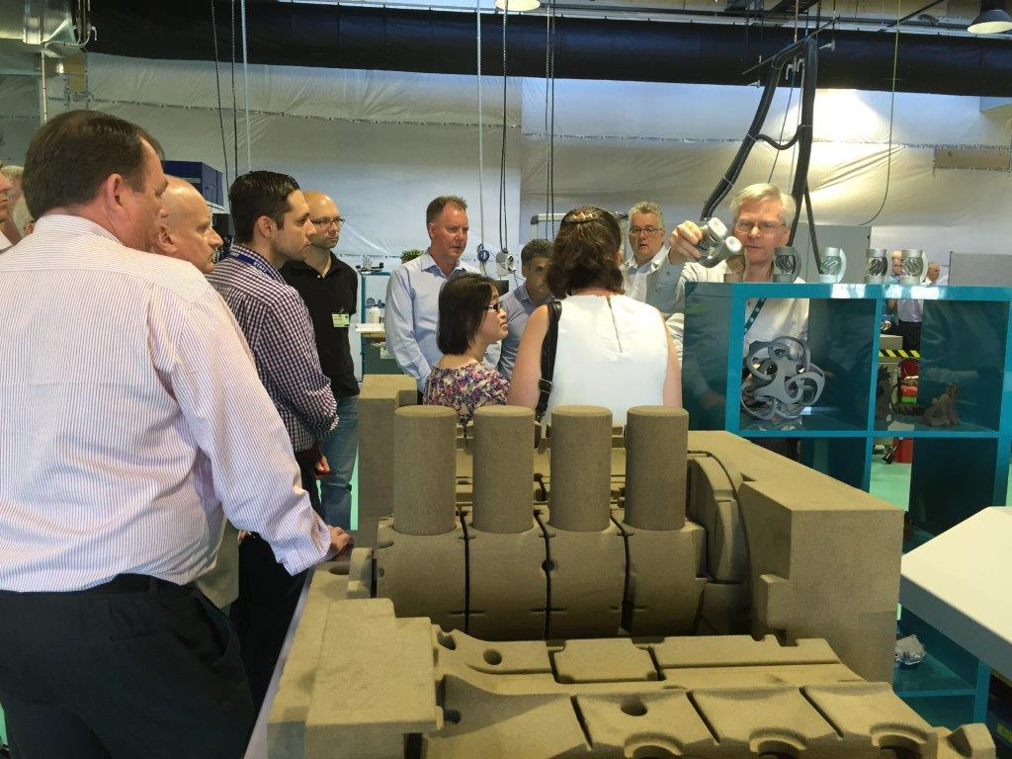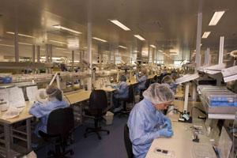
Pictures: AMF Forum members at CSIRO Lab21, Melbourne, and Cook Medical, Brisbane.
Clients nominate their own companies where business leaders conduct a plant tour and describe why their factories are best practice. The Forum and AuManufacturing promote the tour through Linkedin, newsletter, direct marketing and the website, handle the collection of attendee names, and publish an after tour wrap up of member experiences. Either Peter Roberts or Brent Balinski attend to host the event, recommending and acknowledging the sponsor.
What you get:
- Exclusive access to manufacturers in an environment of manufacturing transformation and success.
- A plant tour showcasing an equipment installation or service success.
- Promotion in the Forum, newsletter and the web before and after the event.
- The power of personal recommendation from your own client and the Forum.

What it costs:
- Clients provide coffee and refreshments at the visit welcome, usually first thing in the morning.
- A fee of $1,000 plus GST.
- Travel costs for Peter Roberts or Brent Balinski if the event is outside of Adelaide or Sydney.

Contact:
Peter Roberts
info@aumanufacturing.com.au
PO Box 711, Hove, South Australia 5048
Phone: 0419 140 679

Publisher
Australian Manufacturing Forum
ABN 22 682 643 900

BOOKING CONFIRMATION FORM
Confirm your booking by filling out the form below. Scan and email the returned form to brent@aumanufacturing.com.au

Please forward all booking enquiries and promotional artwork and pictures to
info@aumanufacturing.com.au
AuManufacturing Advertising Department
PO Box 711, Hove, South Australia 5048
Phone: 0431 510 339

Publisher
Australian Manufacturing Forum
ABN 22 682 643 900

Booking name | Created date
Prepared by | Account name
Address | Order number

Customer and advertiser
Customer name | Organisation name
Organisation | Contact person
Address | Phone
 | Email
Phone
Email

Product | Line item description | Start date | End date | Sales price
Best Practice Tour plus promotion
Total price:

PAYMENT DETAILS
Total advertisement price: $ to be paid by direct deposit
Bank: Commonwealth Bank of Australia
Account name: Australian Manufacturing Forum
BSB: 062-105
Account number: 1091 3171

Terms and conditions for advertising material
These terms and conditions apply to the advertiser (herein referred to as “the client”) and the publisher, the Australian Manufacturing Forum (herein referred to as “AMF”). The information in this booking form will be treated as confidential by both the client and the AMF.
Advertising material must not contain any profanity, be defamatory, breach a confidence, or infringe any laws, regulations or statutes. It will be accepted on the assumption the client has copyright of the material and the right to mention any service, individual, entity or product contained within. Material must be submitted seven days before the scheduled date of publication.
Material should fit the specified dimensions contained in the media kit. If significant alterations are needed to make the material usable, then a fee of $100 per hour will be charged to the client for this.
Full and final payment must be made five days or more before the scheduled publication date.
Any cancellation must be made three days or more before the publication date. No refund will be given outside of this period.
The AMF also reserves the right to reject, exclude or cancel advertising at any time.
The client will be refunded for any advertisements that the AMF is unable to publish. In that case, the AMF is not liable for costs greater than the amount the client has paid.
The AMF is not liable for any indirect or consequential losses following publication of the client’s advertising. The advertiser will indemnify and hold harmless the AMF in the event the material published leads to claims, cost penalties, or demands.

